Section 1: Consortium Information
West Hills Adult Education Consortium
Primary Contact Name: David Castillo
Title: Executive Director
Phone: (559) 934-2166
Email: davidcastillo2@whccd.edu

Table of Contents
Section 1: Consortium Information 1
Section 2: Comprehensive Regional Three-Year Plan 3
2.1 Executive Summary 3
2.2 Pre-Planning Assessment 5
Table 1. Regional Service Providers 6
Table 2. Funding for Adult Education Programs and Services 7
2.3 Community Need and Customers 8
2.4 Identifying Goals and Strategies 14
Figure 5. Logic Model 14
Table 3. Progress Indicators 17
2.5 Piloting and Implementation 18

Section 2: Comprehensive Regional Three-Year Plan
2.1 Executive Summary
The West Hills Adult Education Consortium (WHAEC) spans across 3,464 square miles on the west side of the Central San Joaquin Valley. This region is a very rural agricultural section of the Central Valley and includes the west portion of Fresno County and northwest portion of Kings County. Diversity within this large region dictates diverse levels of programing to address dissimilar challenges as varied needs, strengths, and educational requirements of each area vary drastically across the WHAEC service area. This three-year plan focuses on improving delivery of services, program outcomes, as well as to strengthen and expand career pathways. The West Hills Adult Education Consortium will continue to enhance and expand educational programs and program offerings through increased partnerships with educational institutions, workforce development organizations, employers and community members with emphasis on student persistence, completion, and success. The 2018-2019 year has demonstrated increased growth potential and expanded collaboration among all board members, outside agencies, and the communities served. Student numbers at the end of May 2019 confirmed consortium goals of increasing the student base served; 3rd quarter results document approximately 1,826 students, a 5% increase from the previous year’s fourth quarter totals. Two consortium members will be offering additional summer classes, which will further increase total enrollments by the end of the fourth quarter.
Over the past two years, consortium members have recognized the need to demonstrate a high standard of instructional results. This motivated members to increase their own standards by targeting Adult Ed. ACS/WASC Accreditation. Last year, Firebaugh Las Deltas Unified School District was the first to initiate this goal and were able to complete the process and earn their ACS/WASC Accreditation. Upon Firebaugh’s completion, Reef Sunset Unified School District applied for and earned their ACS/WASC Accreditation. Earning this accreditation validates each member’s commitment to ensuring educational excellence and aids toward developing quality and pertinent programs.
Addressing the needs of this region has been a priority since day one; it is this priority that drives much of the instructional programing provided for students. Currently, every consortium member offers ESL/ABE courses; five of the nine total members offer diploma programs and three members offer High School Equivalency (HSE) preparation at six sites in the region. ABE is even combined with diploma classes in some instances to address the gaps and secure attainment of a high school diploma/HSE. Citizenship course success has driven demand for additional courses, six of the nine members offered citizenship classes this year. One college member implemented an ESL Certificate of Achievement, which provides a pathway into either

CTE and/or Academic degree programs. These four level ESL classes are offered as non-credit at WHC-Coalinga and will continue to be offered in subsequent years. WHC-Lemoore is scheduled to offer the same ESL Certificate of Achievement in the fall of 2019 pending curriculum approval. Additional goals include expanding courses for immigrants such as ESL, Citizenship, and Computer Technology; we will also expand ESL/ABE/ASE/HSE availability in the rural communities and expand offerings of high demand short-term CTE courses as indicated in the community survey results.
Although all consortium members conduct CASAS pre and post-testing, student persistence and attrition has been challenging amongst farm laborers and has influenced the low number of post-test applied. Due to these results, a new strategy will identify and address student attrition by providing various formats to improve performance. Additionally, all members work closely with consortium staff to provide student entry records, updates and attendance to track enrollments and demographic information into the CASAS TOPSpro database as mandated by the State CAEP office.
The demand for Career Technical Education (CTE) also continues to increase. It has been noted most students highly value CTE courses as the skills can be directly implemented into their current jobs. This assistance will allowing for increased income and/or a new job that has increased potential for a better quality of life. Persistence and completion rates have been high for most of the CTE programs. WHAEC expanded the number of CTE trainings, which included forklift certifications, truck driving and residential electrical programs. Three-hundred and sixty-seven (367) completed skills trainings at the end of the 3rd quarter. Expanded offerings in welding are currently being scheduled for fall 2019.
The consortium approved hiring a consortium level academic advising specialist fall of 2018 to further assist and guide students to continued growth. The advising specialist disseminates consortium, college and partner agency programs, career options information and helps develop student educational plans with short and long-term goals. This position improves student career planning based on student objectives, assessment and learner outcomes.

2.2. Pre-Planning Assessment
The WHAEC conducted four pre-planning assessments in preparation for addressing the needs of our region in this Three-Year Plan.
- The first assessment, the Human Centered Design (HCD) process began in the fall 2018 with five of our nine members participating in six face-to-face meetings. The HCD process demonstrated the need for improved customer service at both the K12 and community college sites as well as the need for an adult ed marketing plan to better inform the community of course/trainings available in their areas.
- The second assessment, the Program Quality Self-Assessment completed by each WHAEC member, revealed the need for career planning as part of the student’s individual educational plans.
- In the third assessment, the Community & Course Scheduling Survey, we received approximately two-hundred and eighty-nine (289) adult ed student responses from the region. The outcomes for this assessment focused on the demand for in-person ESL, ABE and ASE/HSD/HSE courses as well as CTE (Computer Technology, Security Guard, Janitorial, Maintenance Mechanic & Welding) courses offered in the morning and evening (after 5pm) between the months of October – May.
- Our final assessment was to analyze our 2018-19 third quarter Data Integrity Report as well as NRS Tables, which confirmed the need for closely monitoring student attendance and encouraging students to persist more than 40 hours to increase post-testing results and student educational functioning level (EFL) gains.
Although the WHAEC region covers a large land mass with varied needs, strengths and educational requirements, the WHAEC leadership team has maintained a consistent, effective and relevant communication among its members and partners. Our current WHAEC board meets every three weeks and is engaged to ensure each of the educational areas in this vast region is well represented.
Consortium partners include the following local school districts and colleges: Reef Sunset Unified School District, Firebaugh Las Deltas Unified School District, Coalinga-Huron Unified School District, Mendota Unified School District, Golden Plains Unified School District, Lemoore Union High School District and Crossroads Charter Academy. Our college members include West Hills College-Lemoore and West Hills College-Coalinga. In addition to our nine-member board, regional partner organizations include Kings County Job Training Office and Fresno County Workforce Investment Board.

Table 1.  Regional Service Providers  Provider Name | Provider Type | Address or location(s) where AE services are provided | Program Areas |  |  |  |  |  |  |  | If other, provide a brief description of services provided
 |  |  | ABE | ASE | ESL | CTE | AWD | WR | PA | ACS
Golden Plains Unified | Education | 22000 Nevada St.  San Joaquin, CA 93660 | ☒ | ☐ | ☒ | ☐ | ☐ | ☐ | ☐ | ☒ | Courses for adult learners primarily non-English speaking
Mendota Adult School | Education | 211 Smoot Ave.  Mendota, CA 93640 | ☒ | ☒ | ☒ | ☒ | ☐ | ☐ | ☐ | ☐ | Offers classes for adult learners
Lemoore Union High | Education | 5 Powell Ave.  Lemoore CA, 93245 | ☒ | ☒ | ☐ | ☒ | ☐ | ☐ | ☐ | ☐ | Offers some training courses but mostly focused on high school diploma
Reef Sunset Unified | Education | 205 N Park Ave.  Avenal, CA 93204 | ☒ | ☒ | ☒ | ☒ | ☐ | ☐ | ☐ | ☐ | Provides adult ed classes
West Hills College Lemoore | Education | 555 College Ave.  Lemoore, CA 93245 | ☒ | ☒ | ☒ | ☐ | ☒ | ☐ | ☐ | ☐ | Offers adult courses in a college environment
Coalinga-Huron Unified | Education | 516 Baker St.  Coalinga, CA 93210 | ☒ | ☒ | ☒ | ☒ | ☐ | ☐ | ☐ | ☐ | Delivers classes in job training and adult learning
Crossroads Charter Academy | Education | 418 west 8th St.  Hanford, CA 93230 | ☒ | ☒ | ☒ | ☒ | ☐ | ☐ | ☐ | ☐ | Offers adult courses in and surrounding communities
West Hills College Coalinga | Education | 300 Cherry Lane  Coalinga, CA 93210 | ☒ | ☒ | ☒ | ☒ | ☐ | ☐ | ☐ | ☐ | Adult learning courses on college campus - various sites
Firebaugh Unified | Education | 1976 Morris Kyle Dr.  Firebaugh, CA 93622 | ☒ | ☒ | ☒ | ☐ | ☐ | ☐ | ☐ | ☐ | Provides classes to adult learners
Employment Development Department | Social Services | Fresno, Kings, Tulare County | ☐ | ☐ | ☐ | ☒ | ☐ | ☐ | ☒ | ☐ | Assistance in job related fields (referrals)
Fresno County Office of Education Migrant Program | Social services | Fresno County | ☐ | ☐ | ☐ | ☐ | ☐ | ☐ | ☐ | ☒ | Assistance to migrant families in rural communities -referrals
Proteus, Inc. | Social Services | Fresno County | ☐ | ☒ | ☐ | ☒ | ☐ | ☒ | ☐ | ☐ | Provides assistance in an array of fields (referrals)
Workforce Inc. | Employment | Fresno County | ☐ | ☐ | ☐ | ☐ | ☐ | ☒ | ☒ | ☒ | Support services, job readiness, employment referral

Table 2. Funding for Adult Education Programs and Services

 |  | AEP | Cal-WORKS | CCD  Apportionment | Corrections | LCFF/District  Funds | Perkins V | WIOA II | Other |  | Total
Golden Plains USD | 2019-20 | $83,418 |  |  |  | $125,000 |  |  |  |  | $208,418
 | 2020-21 | $83,418 |  |  |  | $125,000 |  |  |  |  | $208,418
 | 2021-22 | $83,418 |  |  |  | $125,000 |  |  |  |  | $208,418
Mendota USD | 2019-20 | $102,527 |  |  |  |  |  |  |  |  | $102,527
 | 2020-21 | $102,527 |  |  |  |  |  |  |  |  | $102,527
 | 2021-22 | $102,527 |  |  |  |  |  |  |  |  | $102,527
Lemoore Union HSD | 2019-20 | $83,418 |  |  |  |  |  |  |  |  | $83,418
 | 2020-21 | $83,418 |  |  |  |  |  |  |  |  | $83,418
 | 2021-22 | $83,418 |  |  |  |  |  |  |  |  | $83,418
Reef Sunset USD | 2019-20 | $232,550 | $5,000 |  |  | $320,337 |  |  |  |  | $557,887
 | 2020-21 | $232,550 | $5,000 |  |  | $320,337 |  |  |  |  | $557,887
 | 2021-22 | $232,550 | $5,000 |  |  | $320,337 |  |  |  |  | $557,887
WHC-Lemoore | 2019-20 | $83,418 |  |  |  |  |  |  | $20,000 | Basic | $103,418
 | 2020-21 | $83,418 |  |  |  |  |  |  | $20,000 | Skills | $103,418
 | 2021-22 | $83,418 |  |  |  |  |  |  | $20,000 | Initiative | $103,418
WHC-Coalinga | 2019-20 | $83,418 |  |  |  |  |  |  |  |  | $83,418
 | 2020-21 | $83,418 |  |  |  |  |  |  |  |  | $83,418
 | 2021-22 | $83,418 |  |  |  |  |  |  |  |  | $83,418
Coalinga-Huron USD | 2019-20 | $83,417 |  |  |  |  |  |  |  |  | $83,417
 | 2020-21 | $83,417 |  |  |  |  |  |  |  |  | $83,417
 | 2021-22 | $83,417 |  |  |  |  |  |  |  |  | $83,417
Firebaugh-Las Deltas USD | 2019-20 | $83,418 | $20,089 |  |  |  |  | $36,748 |  |  | $140,255
 | 2020-21 | $83,418 | $20,089 |  |  |  |  | $36,748 |  |  | $140,255
 | 2021-22 | $83,418 | $20,089 |  |  |  |  | $36,748 |  |  | $140,255
Crossroads Academy | 2019-20 | $83,418 |  |  |  |  |  |  |  |  | $83,418
 | 2020-21 | $83,418 |  |  |  |  |  |  |  |  | $83,418
 | 2021-22 | $83,418 |  |  |  |  |  |  |  |  | $83,418

2.3 Community Need and Customers
The WHAEC serves an agricultural community in the rural sparsely populated mid-western area of the Central Valley. Its members include seven K-12 school districts and two community colleges, which make up the West Hills Community College District. Agriculture is the primary economy, with a large number of government jobs associated with a large prison in the region as well as the U.S. Navy’s West Coast strike-fighter airbase, which is well established and expanding, presenting economic opportunities. Located in a very rural section of the central valley, the region is a primarily Hispanic minority-majority area. Much of this Hispanic population is immigrant and most have limited English. This agricultural–based economy commonly has low educational attainment levels and great need for a variety of adult educational services.
This region has a high population of Hispanics employed in agriculture related jobs that only require minimal academics and low to medium skill levels. The following includes some data to demonstrate:
According to CAEP 2018-19 regional fact sheet, Hispanics/Latinos make up 61% of the 84,171 population in the region. The proportion of service area residents without a high school diploma is 32% or 27,236 almost twice the State’s percentage of 17%. The English language ability of residents in the region is 29% or 24,057 as compared to the State’s percentage of 21%. The proportion of service area population possessing a Bachelor’s degree is 9%, less than three times the State percentage of 29%. Languages spoken in the home is 90.4% Spanish, more than twice the second most spoken language of Punjabi.
These statistics demonstrate the need to address the lack of education in this region. As Hispanics make up the majority of the rural population, the group has been identified as ”in high need of assistance” with most having limited English language, experiencing educational barriers, and commonly are identified as having low employment skills. WHAEC will continue to address these needs by providing English as a Second Language (ESL), High School Equivalency, and Citizenship courses as well as Career Technical Education courses to assist them in obtaining the advanced skills required for many agricultural mid-level related jobs and/or to encourage entrance into postsecondary education.
This region has historically been an underserved area with Hispanic immigrants traditionally holding most of the agricultural related jobs. These jobs are typically seasonal, low wage paying and have low education and skills requirement. In addition, although agriculture has had to endure many challenges, they have succeeded by incorporating multiple new technologies. These technologies are now demanding additional education with increased content knowledge and skill-sets levels of their employees. The WHAEC has addressed the educational demands through ESL classes, Basic Skills, and High School Diploma/HSE programs and is working with both colleges to address higher-level skills attainment.

The WHAEC currently offers basic skills and ESL courses in all its service area communities. These courses are strategic by level and schedule based on individual location needs. The list of courses includes, but are not limited to Basic Skills, English as a Second Language, Workplace English, Literacy, Citizenship, Computer Technology, High School Diploma/HSE, and Parenting Success. Courses will continue being offered in traditional and non-traditional schedules to best serve the population accordingly. All course completers are encouraged to continue taking additional academic and transition to post-secondary and/or to short-term Career Technical Education (CTE) courses.
WHAEC members recognize the tremendous need for a variety of short-term CTE courses and pathways. The CTE courses offered in the past are Forklift Certification, Residential Electrical and Truck Driving. In addition to these, plans are underway to add Welding and Maintenance Mechanic courses. These identified skills courses will align with employer need and potential employment and/or continued post-secondary education.
In addition to programs offered by consortium members, the Fresno County Public Library offers an Adult Literacy Program that provide one-on-one tutoring for individuals with low literacy skill, Proteus, Inc. an organization that provides job-training, placement and support services in the Central San Joaquin Valley, also offers adult basic education programming and High School Equivalency preparation.
Golden Hills Adult School in Avenal State Prison offers high school diploma/High School Equivalency programs, which are required of inmates who have not completed a high school diploma or equivalent. The school also offers basic skills for those individuals who are not yet prepared for secondary-level material. WHAEC member West Hills College Coalinga also offers college level courses at the prison.
The WHAEC will continue to expand partnerships with entities that can provide financial and student support systems to ensure a better success rate. Workforce Connection as well as Job Training Office (JTO) in Kings County are well integrated in assisting eligible individuals with supportive services for students and have resources they share with the consortium such as computers and job prep trainings. Proteus Inc. is another agency that provides like services, Department of Social Services has co-enrolled and refers to our courses. All these agencies co-enroll students with WHAEC and provide placement services for those enrolled in consortium programs. Additionally, they share in any additional employment opportunities.
Labor Market Information:
The following figures describe which occupations and industries show the most growth and the most job openings and employment trends through 2027. The WHAEC will utilize this information to plan for future course development/short-term skills trainings.

Figure 1: Top Occupations
Figure 1 shows the top ten occupations with the most job openings and the top ten fastest growing occupations in the WHAEC region:
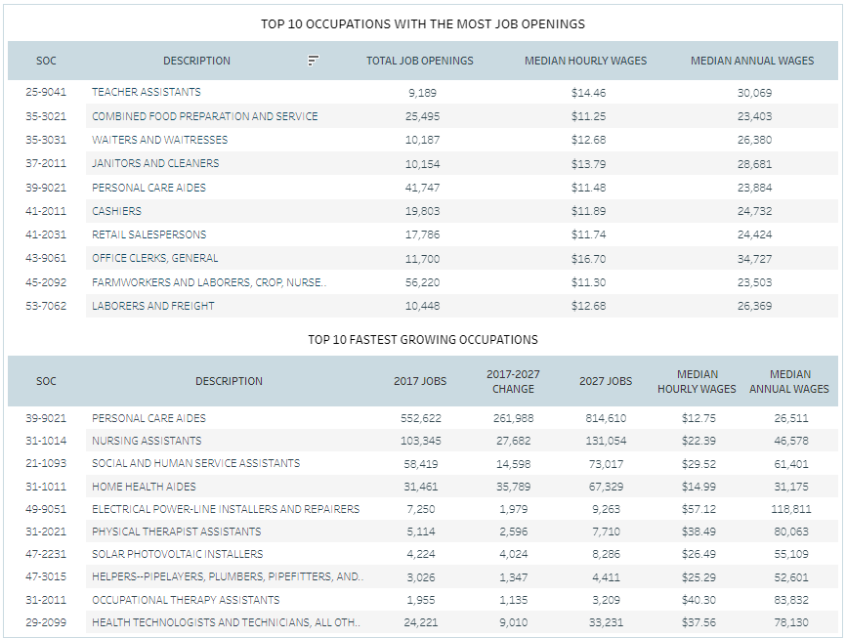

Figure 2: Most Job Openings for 2017-2027
The following occupations demonstrate the most job openings for 2017-2027:
• Office Administrative • Farming, Fishing, Forestry
• Sales • Production
• Food Prep/Service • Personal Care and Service
• Transportation • Building and Grounds Maintenance
• Construction and Extraction • Protective Service
• Education and Library

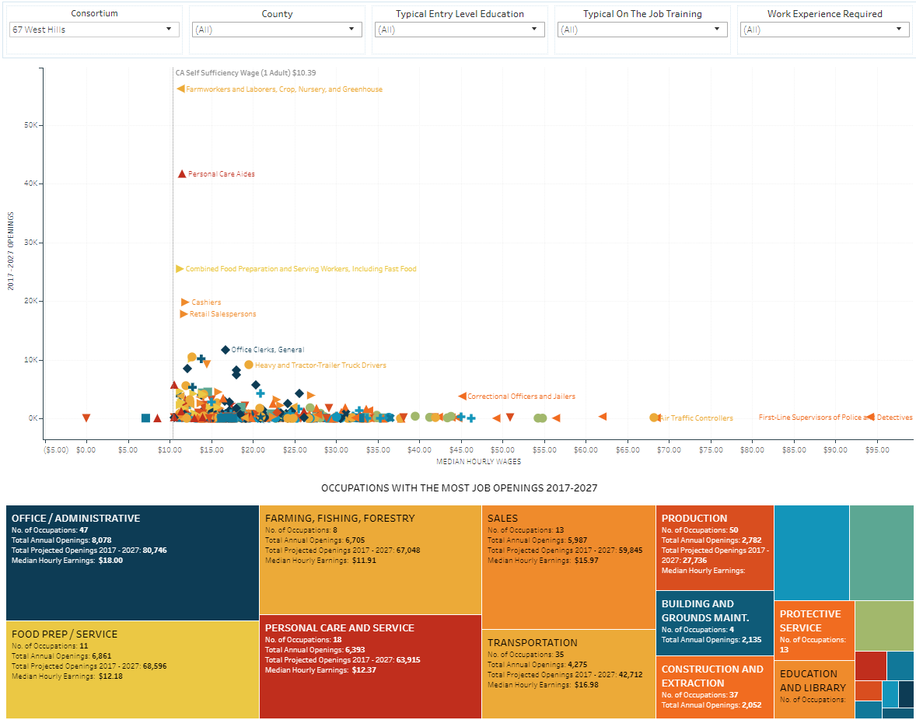

Figure 3: Labor Market Outlook by Industry

Labor Market Outlook
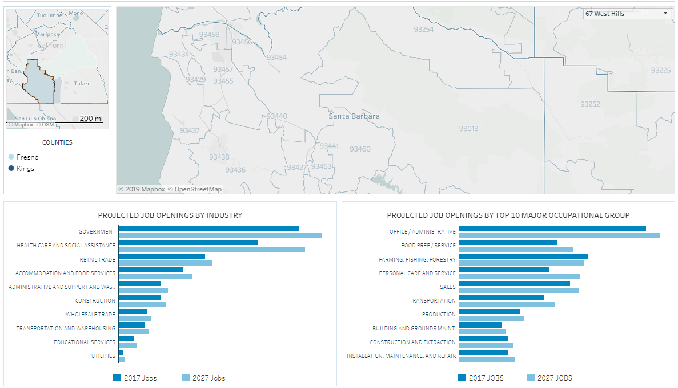

Figure 4: Regional Demographics
The WHAEC will use this information as baseline data to measure impact/growth after the three-year period.
Regional Demographics
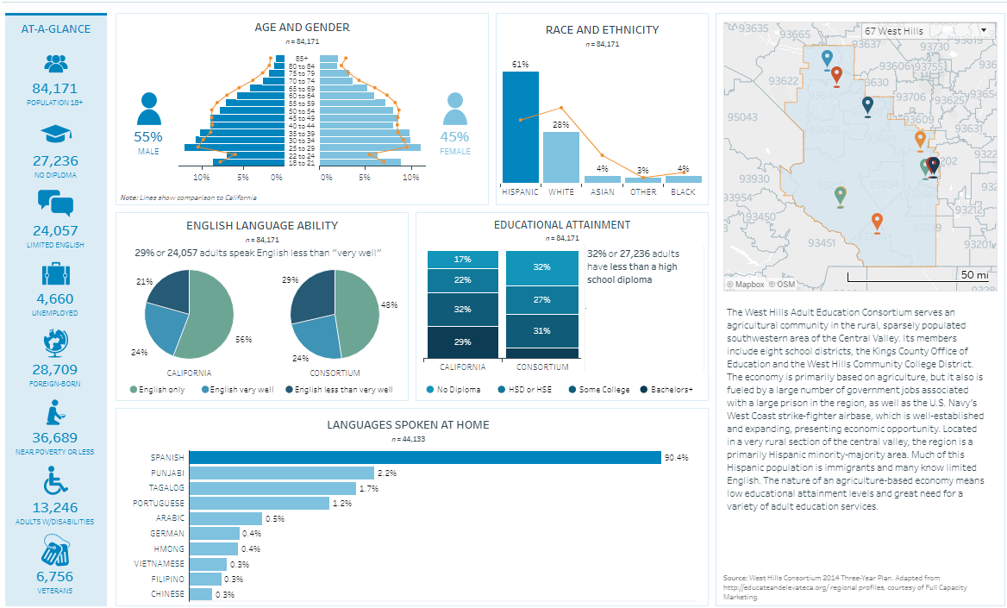

Data sources: U.S. Bureau of Labor Statistics’ Current Employment Statistics and Quarterly Census of Employment and Wages industry employment, and Occupational Employment Statistics data.
http://caladulteddev.scoe.net/2019FactSheets

2.4 Identifying Goals and Strategies
(Figure 5.) Goal 1: Improve WHAEC persistence rate among member sites to close gaps in the region.
Inputs | Activities | Outputs | Immediate (Short-Term) Outcomes | Intermediate Outcomes | Long-Term Outcomes/ Impact
In order to accomplish our set of activities we will need the following: | In order to address our problem or asset we will accomplish the following activities: | We expect that once accomplished, these activities will produce the following evidence or service delivery: | We expect that if accomplished these activities will lead to the following changes in the next year | We expect that if accomplished these activities will lead to the following changes in 1-3 years | We expect that if accomplished these activities will lead to the following changes in 3-5 years
• Create a process for  addressing student  retention  •Consortium support  Staff meetings with site  attendance  contact/instructors | •Meet with consortium  members and  instructors to gather  input and ownership  • Review attendance on  a weekly basis  • Make phone calls to  students absent  previous week  • Refer students to  Social service agencies  for support services as  needed | • Increased student  retention  • Improved learner gains  • Increased pre-posttest  pairs  • A better  understanding  of student barriers  • Student sense of  belonging and  engagement  • Increased rapport  between  instructor/students | • Improved persistence rate  • A higher rate of program  completers | • Persistence rate  increase of 10% each  year  • Completer rate of  10% each year | • Enhanced pre-  posttests  pairs and educational  functional level gains  • Increased post-  secondary enrollment/  employment  outcomes
Assumptions |  |  | External Factors
Through a close monitoring of weekly attendance, consortium staff will improve student retention and persistence. |  |  | Agricultural seasonal work cycle  Child care  Transportation  Fear

(Figure 5) Goal 2: Create a marketing plan to disperse adult ed course schedule of courses to rural communities in the region
Inputs | Activities | Outputs | Immediate (Short-Term) Outcomes | Intermediate Outcomes | Long-Term Outcomes/ Impact
In order to accomplish our set of activities we will need the following: | In order to address our problem or asset we will accomplish the following activities: | We expect that once accomplished, these activities will produce the following evidence or service delivery: | We expect that if accomplished these activities will lead to the following changes in the next year | We expect that if accomplished these activities will lead to the following changes in 1-3 years | We expect that if accomplished these activities will lead to the following changes in 3-5 years
• Develop a marketing  Plan  • Increase social media  and update WHAEC  website | • Invite WHAEC  members/partners to a  meeting to outline  specific elements and  target areas  • Arrange meeting with  WHCCD Marketing staff  to develop a plan of  action | • Action plan to  disseminate course  flyers by semester  (English/Spanish)  • Online access to  pertinent information  regarding WHAEC  courses/programs | • Expand awareness of  regularly scheduled courses  in the communities served  • Expand awareness of  WHAEC course offerings  via multiple media outlets  (English/Spanish) | • Increased number of  enrollments by a  minimum of 10%  • A 10% increase in  student enrollments | • Intensified knowledge  and community  awareness of  the delivery of  educational programs in  communities served  • A robust community  awareness of WHAEC  adult ed courses/  programs in the region
Assumptions |  |  | External Factors
Implementing a marketing plan will systematically enhance community awareness of adult ed programs in the region thus increasing enrollments. |  |  | Language barriers  Computer illiteracy  WHCCD Marketing constraints  Funding availability

(Fig. 5) Goal 3: Strengthen WHAEC transition pathways to increase postsecondary education/careers/employment opportunities
Inputs | Activities | Outputs | Immediate (Short-Term) Outcomes | Intermediate Outcomes | Long-Term Outcomes/ Impact
In order to accomplish our set of activities we will need the following: | In order to address our problem or asset we will accomplish the following activities: | We expect that once accomplished, these activities will produce the following evidence or service delivery: | We expect that if accomplished these activities will lead to the following changes in the next year | We expect that if accomplished these activities will lead to the following changes in 1-3 years | We expect that if accomplished these activities will lead to the following changes in 3-5 years
• Increase student  academic advising  • Partnerships and  additional CTE  programs | • Develop an  academic/training  transition plan for  each student enrolled  in WHAEC programs  • Assess current CTE  program requirements  to determine language  requirements and  suitability for students | • Complete an  academic/training  Pathway for students  to follow at whatever  stage of their  education/training  • Enhanced engagement  between learners and  adult ed/college staff | • Increased number of  students with a completed  academic/training  transition plan  • Increased completion of  certificated programs  • Increased number of  students transitioning to  postsecondary/training  programs | • Enhance the number  of completed  transition plans by  25% each year  • A 10% increase in the  number of students  transitioning to post-  secondary/training  programs | • 75% of students enrolled  each year will have  completed an  academic/training  transition plan  • An enhanced  understanding of  academic and career  pathways available  • A 10% increase of students  enrolling in post-  secondary education  programs
Assumptions |  |  | External Factors
Academic advising and completion of an academic/training transition plan will increase student’s knowledge of educational/training pathways and enrollment in postsecondary programs. |  |  | Limited short-term CTE programs in the area  Limited job opportunities in rural areas other than Agricultural Industry  Funding availability

Table 3. Progress Indicators

- By July of 2020 analysis of Data Integrity Reports and NRS tables will demonstrate a 10% increase in persistence rate

- By July of 2020 WHAEC will demonstrate a 10% increase in pre-posttest pairs

- By June of 2020 WHAEC will develop a marketing plan

- By July of 2021 WHAEC will develop a social media page and update website

- By June of 2020 WHAEC will increase the number of completed academic/training transitions plans by 25%

- By June of 2022 WHAEC will enhance number of students transitioning to postsecondary by 15%

2.5 Piloting and Implementation
WHAEC will implement the following new strategies to improve program performance and address the training needs of our rural communities and region.
- The WHAEC will implement a “Persistence & Assessment” strategy to address low persistence levels as well as low post-testing percentages. This strategy will require weekly attendance from all member classes, which will be monitored by the Training & Development staff at the WIT. This will inform staff of absences which will be quickly addressed. Staff will call students to find out why they were absent and if there is, a way staff can assist. Staff will determine if there needs to be a referral to a social service agency and share contact information with both student and agency. In some instances, they will also be referred to the Academic Advising Specialist for further follow-up. We believe this strategy will assist with persistence and increase the number of students with a post-test and educational functioning level gains. This new strategy of reviewing attendance weekly will enhance the ability to do follow-ups and better assist students before they fall too far behind in instruction. Initial trial showed positive results with students attending more regularly while reaching post-test preparedness.

- WHAEC members will implement a Data & Accountability Sub-Committee made up of consortium members to evaluate member Data Integrity Reports and NRS Tables on a quarterly/annual basis to determine progress toward improving performance, student persistence, and outcomes. Each member’s rate will be calculated to monitor growth. In cases where growth continues to be low, consortium-level staff will work those members to provide additional support and improve their rate by the end of the following quarter. Persistence rates for each member will be assessed at end of each year to determine success and challenges toward improving the consortium level persistence rate. WHAEC will utilize its current persistence rate as a baseline moving forward. Anticipated results are an increase in persistence rate by 10% at the end of the first year and 10% each subsequent year for the 3-year period.

- WHAEC will research and build new CTE courses in the following short-term skills training areas.

• Computer Technology • Maintenance Mechanic
• Security Guard • Janitorial
• Welding

Success will be measured by the skill-levels attained, number of students completing the course, employment attainment/retention, and salary/wage increases.

